All sources are from Mason, K. (2007). *Experience of nationhood: modern Australia since 1901*. 5th ed. McGraw Hill:Sydney.

**Source 1**

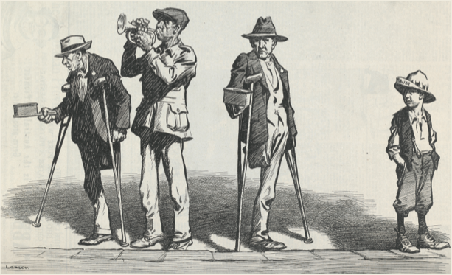

**Source 2**

As Australia’s population grew and Australian cities began to expand, there were major changes to social values and lifestyle. In the 1920s it was women more than men who began to challenge the old ways of the past. Young women now demanded greater freedom, equality and independence and they quickly embraced the changes in lifestyle and manners that came with the 1920s. It was a time for breaking out, and a time for questioning and changing the old values and behaviour and enjoying the good life.

**Source 3**

Modern ideas, modern ‘dress’, modern plays, modern picture shows, modern conversation, and many other ‘modern’ dangers seem to sapping the purity of mind of our modern girlhood … A generation ago the lowest of the slum frequenting would be ashamed to be seen smoking in public, yet today even some Catholic and convent bred girls have no compunction about a ‘whiff in public’. Who a generation ago would even have seen a girl or woman taking intoxicating liquors?

**Source 4**

